First Install Node Modules In Both Frontend and Backend Folders Seperately.

We can run both using the “npm start” command.

Then Put The local mongodb database link in .env file in backend folder.

The database should have following entries:

1:orders

2:products

3:users

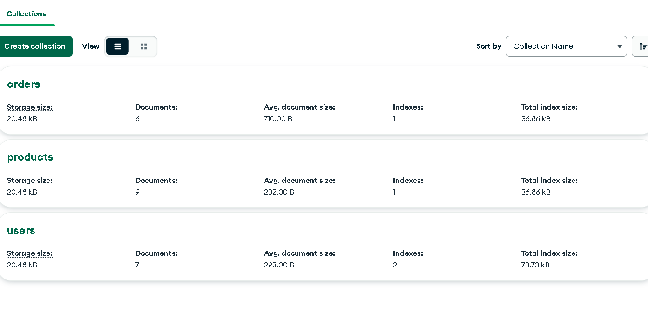

For now, we must add products manually through postman for order processing. Only admin can add products, so we have to use token for adding products. We also must create an admin user through postman first and login as admin. Following is the schema for products and users.



